4.1 T-SQL views, functions & stored procedures

Views:
You can create a simple T-SQL View like this:
CREATE VIEW dbo.vw_Employee_GetJack AS
SELECT
EmployeeId
, Name
, Age
from dbo.Employees
WHERE Name like 'Jack%';

select * from dbo.vw_Employee_GetJack
- Transformed data are not stored in a view, the result is calculated at query time.

- You can create a View from another View (but be careful, this can lead to poor performance, and difficult to understand/ maintain

- You cannot specify parameters for a View (this is possible with functions and stored procedures)

- Reading a SQL View into a semantic model will fall back to DirectQuery (Direct Lake not possible).

SQL Functions:
CREATE FUNCTION dbo.fn_Employee_FirstNameSearch ( @firstname varchar(20) = '' )
RETURNS TABLE
AS
RETURN
(
SELECT
EmployeeId
, Name
, Age
from dbo.Employees
WHERE Name like @firstname + '%'
) ;

-- Test the function
select * from dbo.fn_Employee_FirstNameSearch('Sarah')
- Useful for packaging up logic, which can be parameterized

- Only SELECT statements, can never edit the underlying data (using UPDATE/ INSERT etc)

- Can be called from DDL statements, or from within Stored Procedures, or a View

- Can't be orchestrated (directly) from a data pipeline (although you can embed in a stored proc).

- Allows one or many input parameters

- Output type should also be a Table

Stored Procedures:
-- stored procedure with input parameter
CREATE PROCEDURE dbo.sp_Employee_GetByFirstName @firstname varchar(20)
as
select * from dbo.Employees
where Name like @firstname + '%'

exec dbo.sp_Employee_GetByFirstName 'Jack'

- Ability to define input AND OUTPUT parameters

- Are called using EXEC (not as part of a select statement)

- Can call other stored procedures

- Can also give access to people to the Stored Procedure (and not the underlying dataset)

- Can be embedded in a data pipeline (with parameters passed)

- Ability to do INSERTS, UPDATES, DELETES

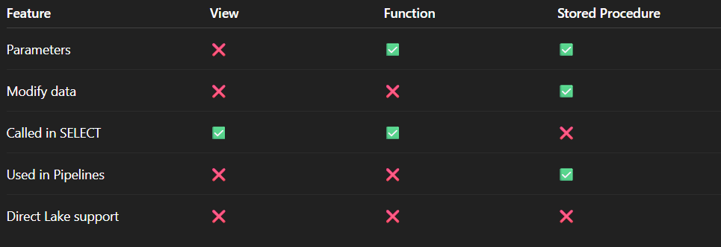
Comparison:

Final takeaway
- Use Views & Functions for read-only logic.

- Use Stored Procedures for orchestration, pipelines, and data changes.

